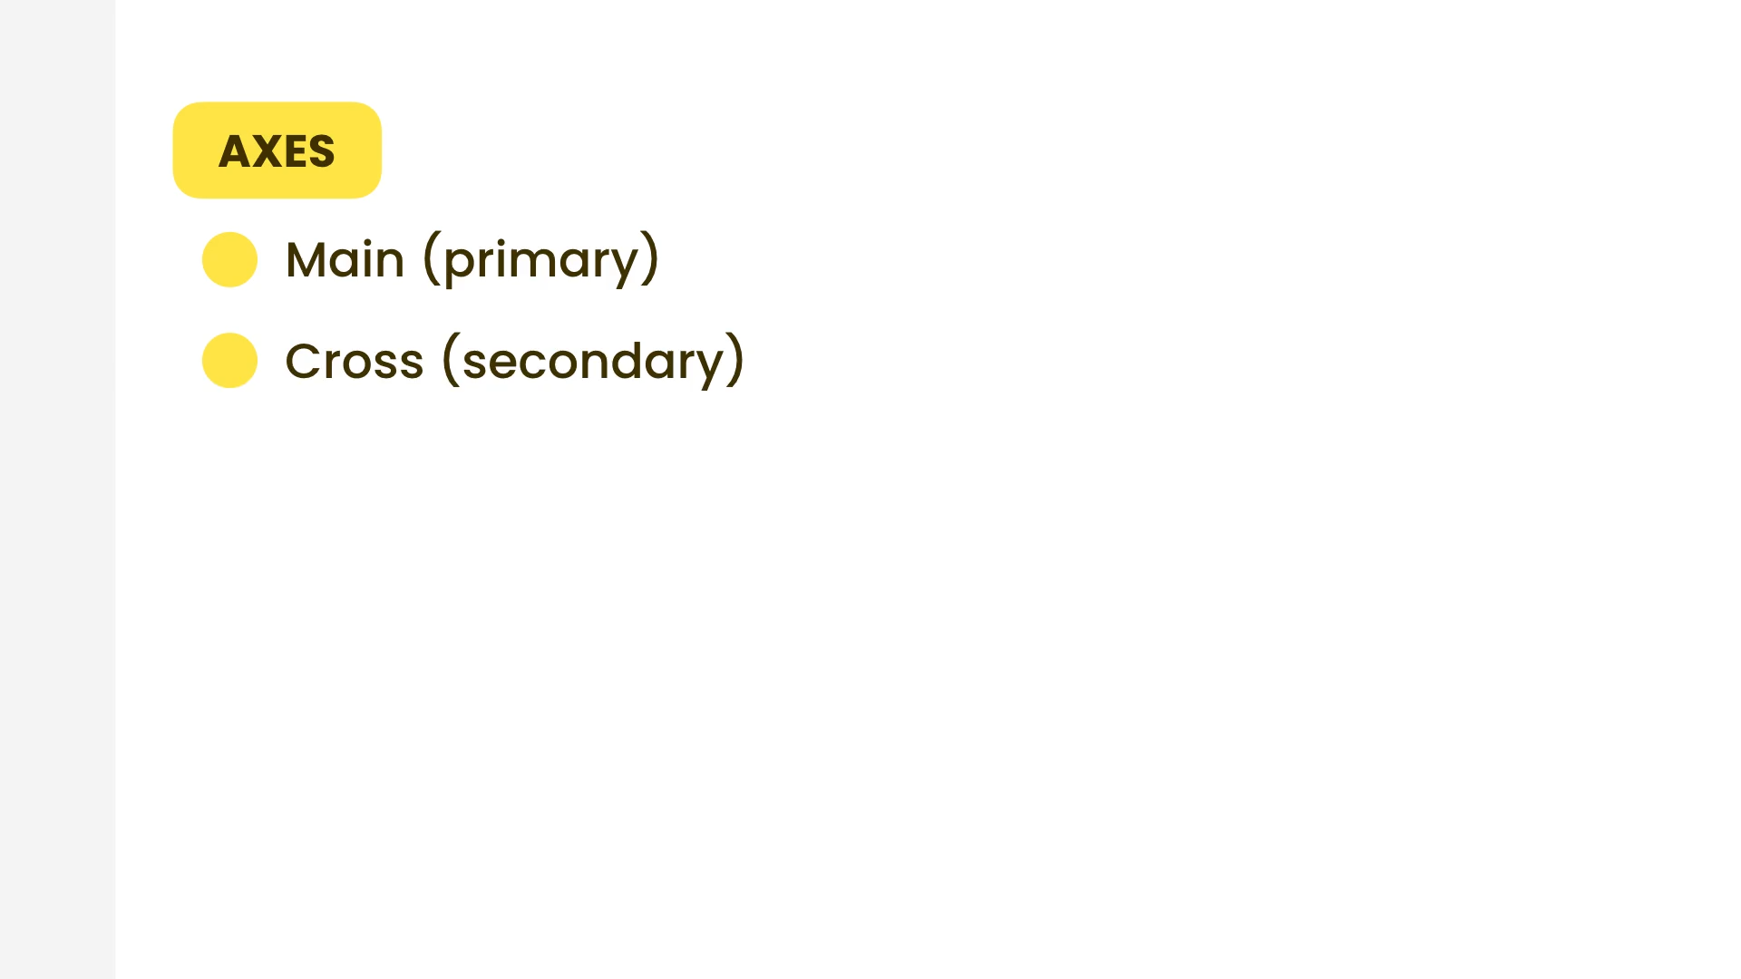

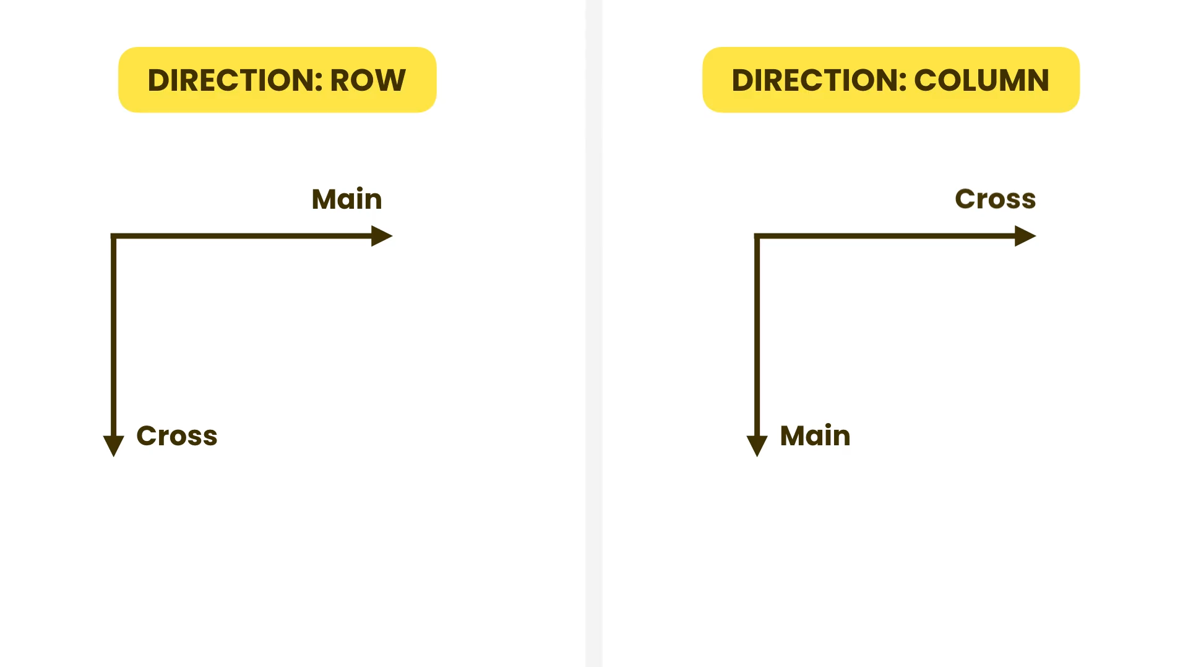

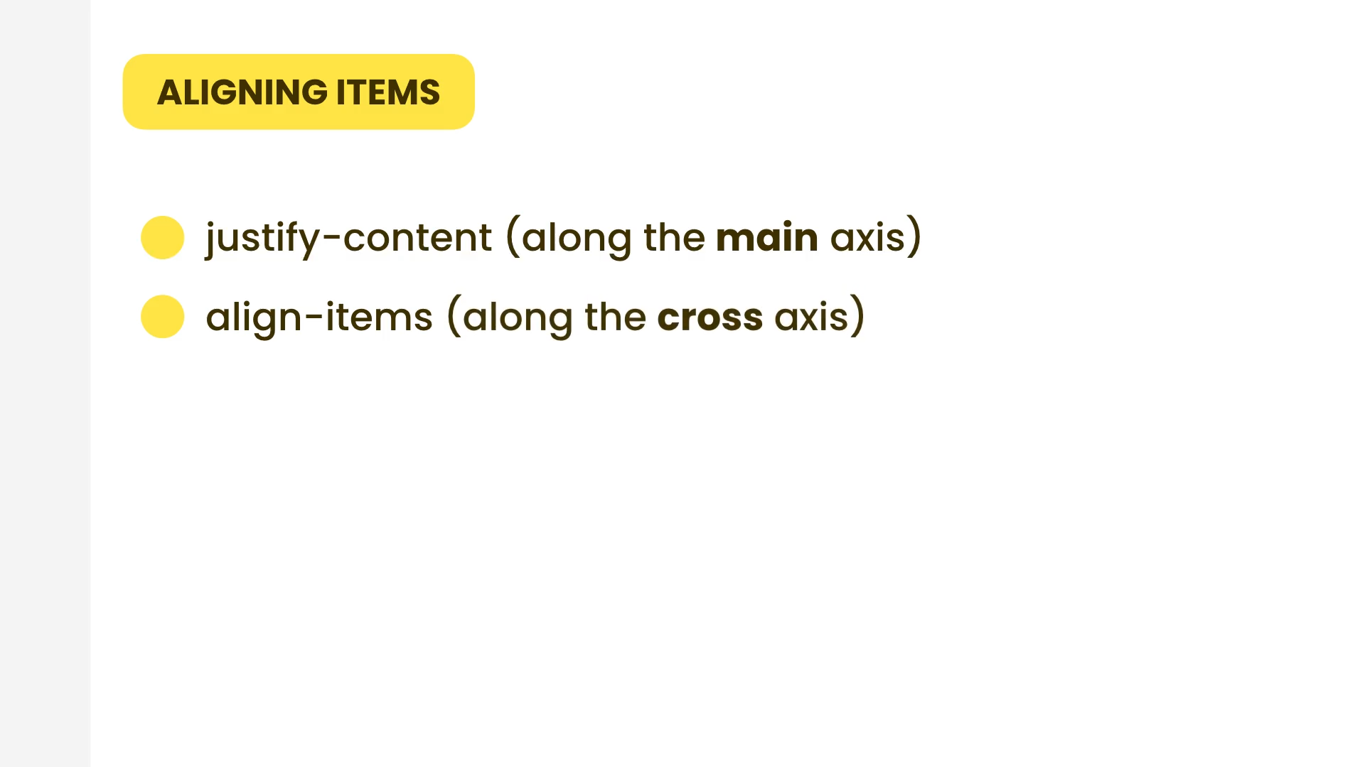

justify-content

flex-start

Default value. Items are positioned at the beginning of the container

flex-end

Items are positioned at the end of the container

center

Items are positioned in the center of the container

space-between

Items will have space between them

space-around

Items will have space before, between, and after them

space-evenly

Items will have equal space around them

stretch

If the combined size of the items along the main axis is less than the size of the alignment container, any auto-sized items have their size increased equally (not proportionally), while still respecting the constraints imposed by max-height/max-width (or equivalent functionality), so that the combined size exactly fills the alignment container along the main axis.

|  |  |
| --- | --- |
| Class | Properties |
| justify-normal | justify-content: normal; |
| justify-start | justify-content: flex-start; |
| justify-end | justify-content: flex-end; |
| justify-center | justify-content: center; |
| justify-between | justify-content: space-between; |
| justify-around | justify-content: space-around; |
| justify-evenly | justify-content: space-evenly; |
| justify-stretch | justify-content: stretch; |

align-items

|  |  |
| --- | --- |
| Class | Properties |
| items-start | align-items: flex-start; |
| items-end | align-items: flex-end; |
| items-center | align-items: center; |
| items-baseline | align-items: baseline; |
| items-stretch | align-items: stretch; |